Building Scalable APIs: A Practical Guide Using Java
In today’s software development landscape, building scalable and maintainable APIs is critical for robust backend systems. Whether you are creating a small product or an enterprise-grade platform, your API structure defines how your services interact and grow. In this blog, we’ll explore how to build scalable RESTful APIs using Java, along with some best practices for designing modular and production-ready backends.
🧩 Why Scalability Matters
Scalability ensures that your API can handle an increasing number of users or requests without degrading performance. Poorly designed APIs often become bottlenecks, affecting the entire application experience.
⚙️ Tech Stack Overview
- Language: Java 17+
- Framework: Spring Boot
- Architecture: RESTful Microservices
- Database: MySQL / PostgreSQL
- Tools: Postman, Swagger UI, Spring Actuator, Docker
🛠️ Steps to Build Scalable REST APIs
1. Use Layered Architecture (Controller-Service-Repository) : This approach separates concerns and improves maintainability.

// Controller
@RestController
@RequestMapping("/api/products")
public class ProductController {
private final ProductService service;
@GetMapping public List<Product> getAll() {
return service.getAllProducts();
}
}
2. DTO Pattern for Clean Data Transfer
Avoid exposing your entities directly. Use Data Transfer Objects (DTOs) to structure incoming and outgoing data.
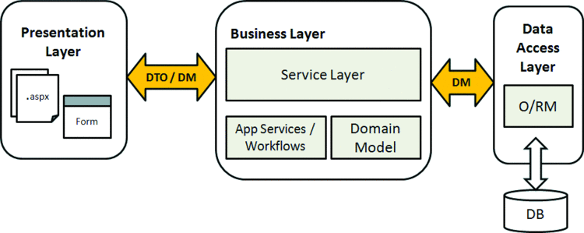
public class ProductDTO {
private String name;
private double price;
}
3. Handle Exceptions Gracefully
Use @ControllerAdvice and @ExceptionHandler for centralized error handling.
@RestControllerAdvice
public class GlobalExceptionHandler {
@ExceptionHandler(ResourceNotFoundException.class)
public ResponseEntity<?> handleNotFound(ResourceNotFoundException ex) {
return ResponseEntity.status(HttpStatus.NOT_FOUND).body(ex.getMessage());
}
}
4. Paginate & Filter Responses
Don’t return everything at once—especially in production environments. Use pagination via Pageable.
@GetMapping
public Page<ProductDTO> getAll(Pageable pageable) {
return productService.getPaginatedProducts(pageable);
}
5. Use Swagger/OpenAPI for Documentation
Integrate Swagger using SpringDoc OpenAPI:
<dependency>
<groupId>org.springdoc</groupId>
<artifactId>springdoc-openapi-ui</artifactId>
<version>1.6.14</version>
</dependency>
Access docs at http://localhost:8080/swagger-ui.html.

6. Secure Your APIs
Use Spring Security and implement OAuth2/JWT for token-based authentication.
OAuth2
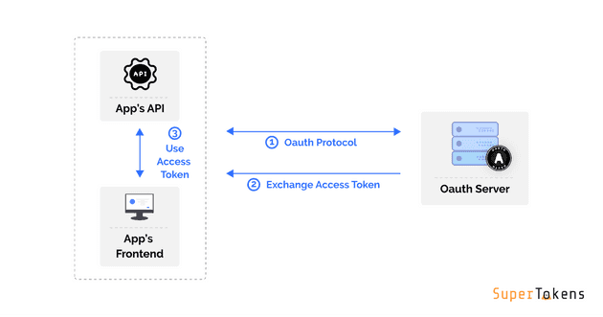
JWT
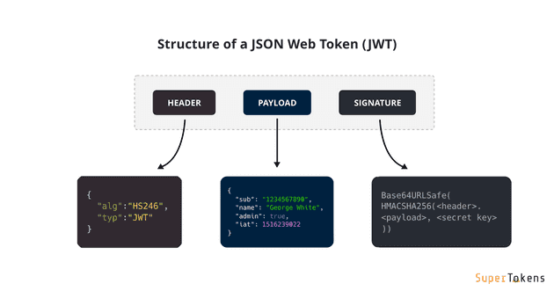
7. Monitor & Optimize
Integrate Spring Boot Actuator and Prometheus + Grafana for real-time monitoring of API health and metrics.
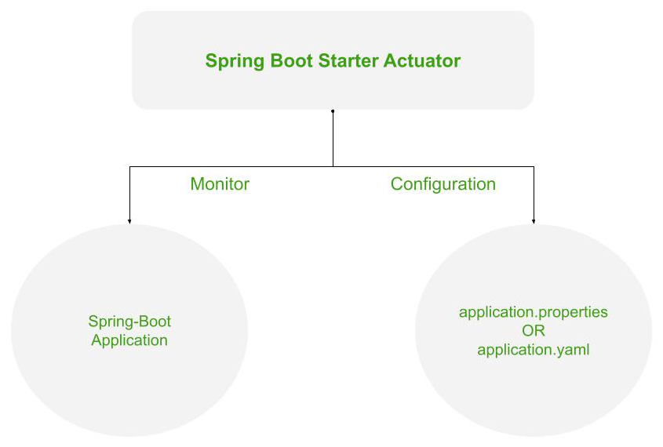
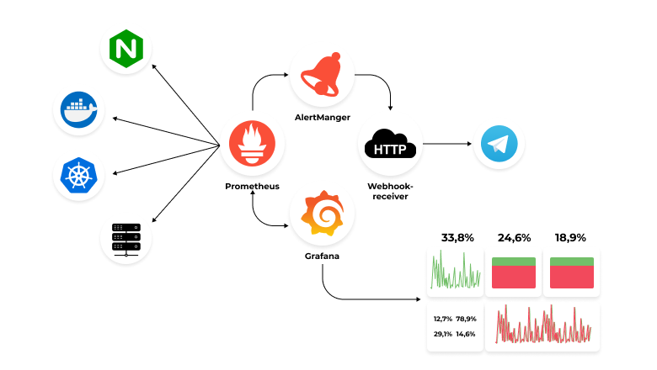
🧪 Testing Tips
- Use JUnit and Mockito for unit and integration testing.
- Test edge cases, null values, and API failures.
- Automate with Postman Collections or REST Assured.

🚀 Deploying Your APIs
Package your application using:- ./mvnw clean package
Run it as:- java -jar target/api-service.jar
For scalability, consider deploying via:
- Docker (containerization)
- Kubernetes (orchestrating services)
- CI/CD with GitHub Actions or Jenkins
✅ Best Practices Summary
- Keep endpoints RESTful (GET, POST, PUT, DELETE)
- Use versioning: /api/v1/products
- Validate inputs using @Valid and @NotNull
- Avoid business logic in controllers
- Always write clean, well-documented code

📌 Conclusion
Building scalable APIs isn't just about handling large traffic—it's about writing structured, modular, and reliable code from the beginning. With Java and Spring Boot, you have powerful tools to ensure your APIs perform well, remain secure, and adapt to growing demands.
📎 Want to learn more or collaborate?
Feel free to connect with me on LinkedIn or explore my GitHub Projects.

